

**Monetary policy-making and forward guidance**

Speech given by

Martin Weale, External Member of the Monetary Policy Committee, Bank of England

At Quintin Kynaston Community Academy Friday 15 November 2013

I am grateful to my colleagues on the Monetary Policy Committee and to other colleagues at the Bank for their comments on an earlier draft.

# Introduction: inflation before the MPC

Thank you very much for inviting me here today. Since you are studying economics, I hope you will need no persuading that my subject is both interesting and important. I would like to start by explaining the task the Monetary Policy Committee faces. I will then say something about how we go about our business and conclude by offering some observations on the current state of the economy.

It may seem to you a silly question to ask why money has value. A century ago money was valuable because it was made out of gold, which was and remains a valuable commodity. Now, the best answer I can give is that money is valuable only because people expect it to be valuable in the future. If you have a

five-pound note, you expect to be able to buy much the same with it tomorrow as you can today. The job of the Monetary Policy Committee is to ensure that this remains the case. To do this we are required to keep the rate of inflation, a term which describes the annual increase in prices, to two per cent per annum.

Price stability is not something that can be taken for granted. In the mid-1970s, when I was slightly older than you are now, prices were rising by over twenty per cent a year (Chart 1). I said earlier that we expect money to be worth much the same tomorrow as it is today. In 1975 that was true from one day to the next, but not over periods of just a few months. I remember I had a job in a supermarket; one of the ladies I worked with said she was thinking of buying a coat as an investment. Prices were rising so rapidly that it made sense to her to buy things even if they were not needed for several months.

High inflation, of the kind I remember from the 1970s, made borrowers better off but people who had invested their savings, as they thought, safely, worse off. Overall the impact was damaging. Voters did not like it. Politicians concluded that they needed to develop institutional arrangements which would prevent that sort of thing happening again.

A variety of policies were tried, but with limited success. Inflation was lower in the 1980s than it had been in the 1970s, but it remained unstable and reached ten per cent by the end of the decade. In 1990 Britain joined the Exchange Rate Mechanism (ERM) of the European Community. This was an arrangement for linking the value of the pound to the currencies of other European countries. The hope was that if we tied our currency to West Germany’s Deutsche Mark, then one of Europe’s most stable currencies, we would come to share Germany’s much lower inflation rate. But this policy proved to be a spectacular failure; in September 1992 people stopped believing that we could maintain the link and sold pounds as fast as they could get hold of them. The pound was forced out of the ERM.

After this experience politicians suggested an inflation target. In 1997 the new Labour government set up the Monetary Policy Committee, of which I am a member, and made it responsible for adjusting the interest rate to keep inflation close to a target of two per cent per annum set by Parliament. You can read our remit

from the [Chancellor of the Exchequer](http://www.bankofengland.co.uk/monetarypolicy/Documents/pdf/chancellorletter130320r.pdf) (2013). The minutes of our meetings are also freely available ([Monetary Policy Committee, 1997-2013](http://www.bankofengland.co.uk/publications/minutes/Pages/mpc/default.aspx)).

To cut a long story short, our job is to ensure that people buy coats when they need them and not as investments. But, equally, the modest positive inflation rate has the effect that people do not put off buying coats because they will be cheaper next year. Countries suffering from falling prices (deflation) also suffer from weak spending. While it may not be clear what is the cause and what is the consequence, there is little doubt that deflation can reinforce a period of weak demand and economic depression. That is why our job is to keep the rate of inflation close to two per cent, and not to deliver a rate of two per cent or lower.

Chart 1: Annual Inflation in the UK.

**Percentage change**

30

25

RPI

CPI

20

15

10

5

0

-5

Two measures of inflation are published by the Office for National Statistics. The target for the MPC was originally 2 ½ % p.a. measured by the Retail Price Index (RPI), but was changed to 2% p.a. measured by the Consumer Price Index (CPI) in 2003. The RPI is known to be a poor measure of inflation and is not a national statistic

1960

1962

1964

1966

1968

1970

1972

1974

1976

1978

1980

1982

1984

1986

1988

1990

1992

1994

1996

1998

2000

2002

2004

2006

2008

2010

2012

Source: ONS

# Monetary policy yesterday: interest rates and quantitative easing

When the Monetary Policy Committee was set up it was assumed that it would be able to do everything necessary by adjusting the Bank Rate. If demand was running ahead of supply - too much money chasing too few goods - , so that inflation seemed likely to exceed its target, the Committee would raise the

Bank Rate to reduce demand. This would lead to a reduction in spending, or at least slower growth in spending, and inflationary pressures would ease. It might also lead to a rise in the exchange rate, reducing the prices of internationally traded goods in sterling terms and again reducing inflation. If inflation was expected to fall below target, the Committee would reduce the Bank Rate. The mechanisms were described fully by the first members of the [Monetary Policy Committee](http://www.bankofengland.co.uk/publications/Documents/other/monetary/montrans.pdf) (1998).

Until 2008 the system worked well. The rates that banks and building societies charged on loans and paid on deposits were typically closely related to the Bank Rate. When the Bank Rate went up, the rewards to saving

and the costs of borrowing both rose, encouraging people to save more and borrow less. As a result the pressures on demand were reduced and inflation could be brought back to target. A reduction in the Bank Rate had the opposite effect.

The Committee moved the Bank Rate in small steps - a quarter or at most half a percentage point. This was very different from the sort of movements we saw in the 1960s and 70s. Then the Bank Rate was sometimes raised by two percentage points in one go, and in July 1973 it was raised by two percentage points twice in one month. These large jumps are generally considered to be a consequence of political pressures. Because raising Bank Rate made it more expensive for the public to borrow - an unpopular thing with many voters - politicians were reluctant to do so. This often meant that the Bank Rate was kept too low for too long and large rises were eventually needed. The Committee, in contrast, is non-political and has a clear responsibility to control inflation. It does not face political pressures to put things off and makes more timely, more measured, moves.

Setting monetary policy became more complicated in 2008. An unprecedented and, I think it is fair to say, completely unexpected international economic crisis developed. A major international bank, Lehman Brothers failed and, as a result people became reluctant to entrust their money to other banks, at least without the compensation of high rates of interest to make up for the risk they saw of losing their money, a risk which they assumed had much increased. This in turn meant that banks became reluctant to lend, at least on the terms on which people wanted to borrow. The result was that households and businesses cut back sharply on their spending.

The Monetary Policy Committee of the time responded by cutting the Bank Rate sharply, to ½ per cent. It did as much as it could to make borrowing cheaper so as to offset the developing credit squeeze. But in 2009 it decided further support was needed. It considered then, and has done so since, whether it might be possible to reduce the rate further, or even to impose a negative interest rate- to charge banks for looking after their money. Of course, if we did this for any length of time, then banks would start charging their customers for looking after their money. And it would be an uphill task to try to explain to the public that this was a good idea. For this and other reasons we have concluded that ½ per cent is an effective floor ([Bean, 2013](http://www.bankofengland.co.uk/publications/Documents/other/treasurycommittee/ir/tsc160513.pdf)) and further support was instead provided to the economy by means of quantitative easing. You can read more about quantitative easing in an article by colleagues at the Bank ([Joyce, Tong and Woods,](http://www.bankofengland.co.uk/publications/Documents/quarterlybulletin/qb110301.pdf) 2011).

When the Bank undertakes quantitative easing it buys in government debt. When the government borrows it tends to borrow for a fixed period. It agrees to pay interest every six months and the lenders get all of their money back on an agreed maturity date. The government issues bonds, certificates which promise both the interest and the capital repayment. But these are widely traded- people can buy and sell them at prices which change from day to day.

When interest rates fall, the fixed stream of payments promised by a given “gilt”, as bonds issued by the British government are known, becomes more valuable and the market price rises. Conversely when rates rise the prices of gilts fall. If we enter the market and buy up debt, then prices rise. Existing holders enjoy capital gains, some of which they may spend, and new buyers regard holding gilts as less attractive - they may send their money instead. But there are also spillovers to other forms of borrowing on which the returns often move in line with those on gilts. If companies make promises to pay which are nearly as good as those of the government, then you would expect the value put on the bonds they issue to move in much the same way as those of the government. Even the prices of company shares are likely to be affected because, although they do not promise anything to anyone, the stream of dividend income associated with them becomes more valuable when interest rates fall. There may also be some spill-over into house prices.

So, companies find they can borrow more cheaply to pay for investment and share prices and perhaps house prices are pushed up, leading to capital gains for investors and home-owners. The upshot of us buying in government debt is that spending levels overall in the economy are supported.

Since March 2009 we have bought in £375bn of government debt, with the most recent purchases in January of this year. At present no further purchases are planned but, if the economy needs further support, my colleagues and I will vote to increase our holding of gilts.

You may wonder where we find £375bn to buy in all these gilts. It is, after all, rather a lot of money. The answer is that people who sell us debt get paid, in effect, with transfers from the Bank of England to their bank accounts. The banks where they keep these accounts may lend out some of the new deposits but in the end the deposits return to us as reserve balances. In effect government borrowing is transformed from gilts to deposits at the Bank of England. The Bank of England has not just handed money over to bankers. But it has, in effect, printed electronic money to buy up the gilts. Charts 2 and 3 show how our major monetary liabilities, bank notes and electronic money, have risen largely in step with our assets which are mainly holdings of gilts.

At some point, no doubt, we will sell off our holding of gilts and deposits at the Bank of England will fall in line with our sales of gilts. But that lies some way off. The Committee has said that it will not consider selling off gilts until after it has raised Bank Rate from its current level- whenever that may be. And my own view is that we should wait until interest rates have returned to much more normal levels- so that we have plenty of room to support the economy, should the need arise, without carrying out any more quantitative easing.

Chart 2: Bank of England: Major Monetary Liabilities Chart 3: Bank of England: All Assets.

|  |  |  |  |  |  |  |  |  |  |  |
| --- | --- | --- | --- | --- | --- | --- | --- | --- | --- | --- |
|  | Reserve Balances |  |  |  | £ billions | 450 | Other assets  Longer-term sterling reverse repo Short-term open market operations  Ways and Means advances to HM Government  Bonds and other securities acquired via market transactions  2009 2010 2011 2012 |  | £ billions | 450 |
|  | Notes in circulation |  |  |  |  | 400 |  |  | 400 |
|  |  |  |  |  |  | 350 |  |  | 350 |
|  |  |  |  |  |  | 300 |  |  | 300 |
|  |  |  |  |  |  | 250 |  |  | 250 |
|  |  |  |  |  |  | 200 |  |  | 200 |
|  |  |  |  |  |  | 150 |  |  | 150 |
|  |  |  |  |  |  | 100 |  |  | 100 |
|  |  |  |  |  |  | 50 |  |  | 50 |
| 2009 | 2010 | 2011 | 2012 | 2013 |  | 0 | 2013 |  | 0 |

Source: Bank of England Source: Bank of England

# Monetary policy today: forward guidance

Most recently we have tried to provide more information about how we set interest rates by adopting a policy we have called forward guidance. Full details are provided by in [*Monetary Policy Trade-offs and Forward*](http://www.bankofengland.co.uk/publications/Documents/inflationreport/2013/ir13augforwardguidance.pdf)[*Guidance*](http://www.bankofengland.co.uk/publications/Documents/inflationreport/2013/ir13augforwardguidance.pdf)(2013). We have said that we will not raise Bank Rate while the unemployment rate remains above seven per cent (it is currently 7.6 per cent). Despite this, we will consider, but not necessarily implement, an increase in Bank Rate if we think it more likely than not that inflation eighteen to twenty-four months ahead will exceed 2 ½ per cent, or if there is a significant rise in medium term inflation expectations even while unemployment is above seven per cent. We have also said that we will consider raising Bank Rate if the Financial Policy Committee tells us that there is a risk to financial stability which they cannot handle.

The key point in this story is that we are deliberately linking the Bank Rate to the unemployment rate. This makes a great deal of sense if you think that, in the United Kingdom, the main mechanism by which fluctuations in demand translate into fluctuations in inflation is through the demand for labour. When that is strong wages tend to rise sharply pushing up on prices, while, when it is slack as at present, wage growth is moderate.

Our *Inflation Report* provides a projection for unemployment. Chart 4 shows the probability that unemployment will reach seven per cent by a particular date. The chance that unemployment will reach seven per cent by the end of next year is estimated at two in five rising to three in five by the end of 2015. We have not said that the Bank Rate will definitely be raised at that point, but simply that we will review the situation. In deciding what to do we will need to take account of how fast unemployment is falling. If unemployment is falling rapidly, e.g. much faster than our central forecast, we will need to consider the risk of holding rates too low for too long. Even with inflation close to target, it is unlikely to be appropriate for rates to remain at their current level until all spare capacity in the economy has been used up.

Chart 4: Cumulative probability of unemployment Chart 5: Probability that CPI inflation will be at or above having reached the 7% threshold the 2.5% knockout

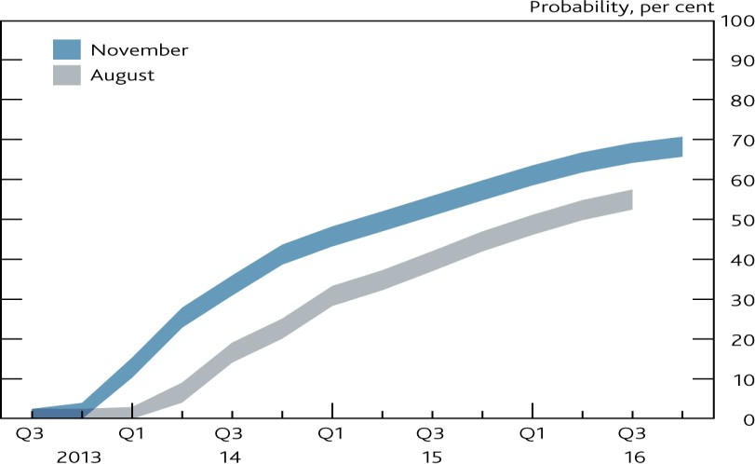 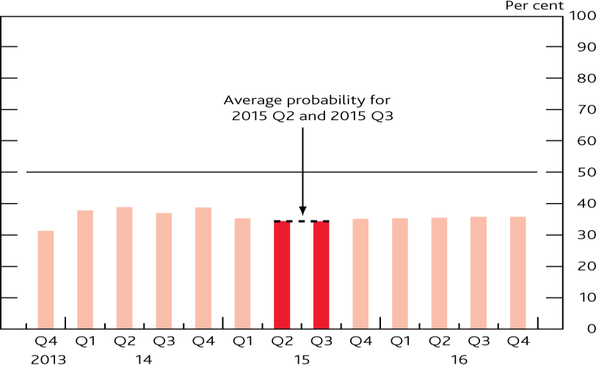

Source: *Inflation Report*. Chart 2. page 7. November 2013 Source: *Inflation Report*. Chart 4. page 8. November 2013

But of course we could be wrong about the primary role of unemployment as a driver of inflation, which is why we have said that we will also consider raising Bank Rate if there are other signs of inflation picking up, perhaps because strong demand leads to firms raising their mark-ups aggressively. Since we produce a forecast which shows the probability that the inflation rate takes particular values over the next two to three years, we can use this to assess the probability that inflation will exceed 2½ per cent eighteen to twenty-four months ahead. Chart 5 shows the probability that we put on this happening. I think all members of the Committee are very comfortable with the picture shown here; the probability could not be expected to fall much lower unless inflation were expected to be appreciably lower than the target set out for us by Parliament.

We also said that we would reconsider if medium-term expectations of inflation increase and I would like to talk rather more about this “knock-out”. An important part of the process by which inflation is held down is through ensuring that people expect it to be close to its target. All the time people make decisions on the basis of how they expect prices to change. The lady thinking of buying a coat as an investment in the 1970s was doing so not because prices had risen by twenty-five per cent over the previous twelve months but because she was expecting something similar in the future. People who negotiate their wages do not intend

to renegotiate every month. So they probably come to an agreement in the light of the extent to which prices are expected to rise while the agreement is in force. If expectations of price increases remain low, it is much easier to limit actual price increases. We have always taken expectations into account for these reasons.

But the fact that, with forward guidance, we have set out policy explicitly with reference to inflation expectations means that we have to be much more rigorous than we were, without forward guidance, about the way in which we measure and interpret inflation expectations. We cannot risk a situation where people say we are deliberately looking the other way if the data show a significant change in inflation expectations.

Our policy of forward guidance has transformed medium term inflation expectations, at least for me, from being one of the issues I take into account, to a key influence on the way I vote. In that sense, of course, the policy of forward guidance reduces the flexibility available when voting. The bar to not responding to any given increase in medium-term inflation expectations is higher than it was without forward guidance. Could I therefore say a bit more about the indicators we can use to judge whether inflation expectations have risen significantly.

There are a number of measures. First of all, because the government borrows, in the way I described, both with securities where the payments are fixed in money terms (ordinary gilts) and where they are adjusted for future inflation (index-linked gilts), it is possible to come to conclusions about expectations of inflation.

Secondly, we can look at other people’s forecasts for inflation. And thirdly we can ask the public. We do all three of these and, as is usually the case, there is no a clear picture. Table 1 shows the indicators of medium-term inflation taken from our November *Inflation Report*).

**Table 1: Indicators of Medium-term Inflation Expectations (per cent per annum).**

|  |  |  |  |
| --- | --- | --- | --- |
|  | Average 2000-2007 | Average since 2008 | Most recent |
| 2-3 years ahead |  |  |  |
| NOP Survey | n/a | 2.9 | 3.0 |
| Barclays Survey | 3.2 | 3.4 | 3.1 |
| Forecasters | 2.0 | 2.0 | 2.2 |
| Markets | 2.6 | 2.7 | 3.0 |
| 5-10 years ahead |  |  |  |
| NOP Survey | n/a | 3.3 | 3.5 |
| Barclays Survey | n/a | 3.8 | 4.0 |
| You Gov Survey | 3.5 | 3.4 | 3.9 |
| Markets | 3.0 | 3.5 | 3.5 |

Source: *Inflation Report*. Table 1. page 34. November 2013.

Like the *Inflation Report* I show the averages both for the period 2000-07 and since 2008. The reason for this is that in the period before 2008 inflation was close to its target of 2 per cent, while since 2008 it has been well above it, with an average value of 3.2 per cent. So, to the extent that expectations reflect recent experience, one might think that the numbers in the first column would be lower than those in the second column. But some of the data were not available before 2008, so a full comparison is not possible.

How might we address the question whether these data show that inflation expectations have moved significantly? When I think about whether expectations have moved significantly, I am talking about expectations relative to the period between 2008 and the introduction of forward guidance. If you compare the last column with the average since 2008, you can see that six of the measures are above their average, Only one, the Barclays Survey two to three years ahead is below its average but the market measure five to

ten years ahead, which is shown equal to its average in the table because of rounding, is in fact below. Suppose that the movements relative to the average were purely random, unrelated to each other, and that being above and below were equally likely- in other words that they were nothing to do with movements in inflation expectations. If I tossed eight coins, I should expect four heads and four tails. The chance of coming up with at least six heads is 37/256, a calculation which was certainly part of A-level Maths when I was at school. So you can see that there is a reasonable probability, about 15 per cent, that this movement is purely random. But if seven measures were above average, the chance of that would be only 8/256 and of course the chance of getting eight heads, all the measures above average if the movements are purely random is only 1/256. So, if a seventh indicator moves above average and seven indicators stay above average for more than one or two months, that will be quite a good indication that inflation expectations have risen, at least to some extent, relative to the average for the period since 2008. These probabilities are, however, distorted if there is some common cause other than inflation expectations influencing the data1.

Even if that is not the case, the measure tells me how likely it is that the pattern I observe is the outcome of a chance fluctuation rather than a systematic movement; it is an indicator of statistical significance. It does not tell me whether the movement in expectations, such as it is, is of economic significance. Here there is no clear guide and my colleagues at the Bank are working on the question of how to extract a signal for underlying expectations from the data we have. I would regard a movement of 0.5 per cent in such an indicator as extremely important. Indeed, I would be very concerned by a movement as large as

0.25 per cent in expectations. The rise in the average indicators in the table is 0.15 per cent and, at present, I am using this as a summary guide to movements in expectations but it is possible, indeed likely, that my colleagues’ work will suggest a better indicator.

There is a further qualification. It would, of course, be quite wrong to react to short-term movements. Even if the average does rise in a way which is statistically and economically significant I would want to be reasonably confident that the rise was likely to persist. That point is particularly pertinent at the moment. The data for the You-Gov survey were collected while there was much public discussion of increases in gas and electricity bills. It is perfectly possible that this influenced the answers people gave. If that is the case - if the increase is a blip for that or any other reason- then we should expect this indicator to fall back over the next three or four months. Furthermore, recently inflation has been unexpectedly low, and that might be reflected in measures of inflation expectations over the coming months. Only if a significant upward movement persists should be we concerned.

Could I be absolutely clear about one other thing? I described monetary policy yesterday as interest rates and quantitative easing and monetary policy today as forward guidance. That is a reasonable headline summary. But, as I said earlier, we will undertake further asset purchases if they are called for. I hope that

1 On occasion it is likely that the measures deduced from financial markets are affected by technical issues driving these markets. The measure of inflation inferred from these relates to the Retail Price Index while our target is set in terms of the Consumer Price Index (see Chart 1). So anything which influences the difference between these two can affect the measures two to three and five to ten years ahead.

the economy is now recovering, and the need will not arise. Nevertheless, as the last five years have shown all too clearly, you cannot be completely sure. Economists who are certain about the future are not to be trusted. I will certainly vote for further asset purchases if I think the economy needs further support at some time in the future.

# The current state of the economy

I would like to conclude by saying something about the current state of the economy and its immediate prospects. I have been a Member of the Committee since July 2010. For most of that time, on each occasion that we produced a forecast, which we do every three months, things seemed worse than they had in the previous quarter. Either the outlook for inflation seemed worse, or the outlook for economic growth seemed worse or, most of the time, both. We understood why this was happening. The oil price was rising; other raw materials were going up in price and there were more general pressures on import prices which we had not expected. At the same time the crisis in the euro area meant that households and businesses felt very nervous; businesses in particular became unusually reluctant to spend.

Since last winter the news has been better. Commodity prices have been stable or falling. The problems of the euro area, although not resolved, have seemed more manageable. People may still be saving up for a rainy day, but they have fewer immediate worries and are more confident that the economic picture is improving. An important trigger for the change of mood was that, in the first quarter of this year, many people had expected that the overall measure of the nation’s output, GDP, would fall, while in fact the first estimate showed an increase of 0.3 per cent, since revised up to 0.4 per cent. In the second quarter the growth rate rose to 0.7 per cent and the current estimate for the summer is 0.8 per cent. We anticipate growth of around

0.9 per cent in the last quarter of this year. Beyond that the Committee’s forecast is that growth will fall back. But I do keep reminding myself that a Bank Rate of ½ per cent is extraordinarily low. In normal times it would provide an enormous stimulus to the economy. To the extent that there is a return to normality, it would not be surprising if the economy grew faster than we have forecast. We show our forecast as a fan chart, as a means of representing the obvious point that we do not know what the future will bring with any degree of certainty. You can see that we give quite a high probability to economic growth being three per cent or more. You can read about this forecast in our most recent [*Inflation Report*](http://www.bankofengland.co.uk/publications/Pages/inflationreport/default.aspx) which was released last Wednesday.

Chart 6: GDP projection based on market interest Chart 7: CPI inflation projection based on market interest rate expectations and £375 billion asset purchases. rate expectations and £375 billion asset purchases.

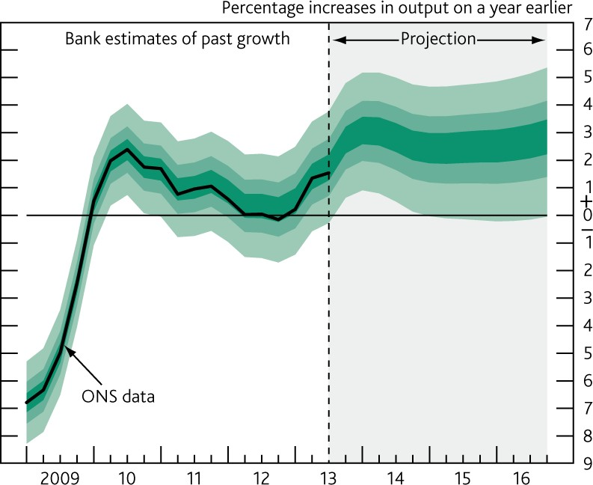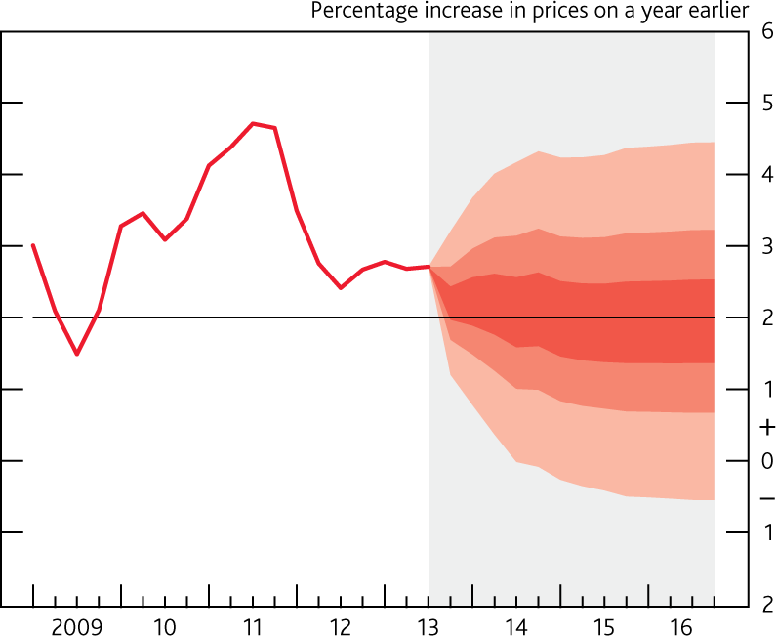

Source: *Inflation Report*. Chart 5.1. page 36. November 2013 Source: *Inflation Report*. Chart 5.2. page 37. November 2013

At the same time as this has happened, inflation has turned out to be appreciably lower than we had thought likely only in August, at the time of our previous forecast. We are currently expecting an inflation rate of

2.2 per cent in the current quarter, while in August we had expected a figure of 2.9 per cent. So as chart 7 shows, while future inflation remains uncertain, we do now, for the first time since I joined the Committee, expect it to be close to its target for the next three years. The recent rise in the sterling has, of course helped with this. But I cannot say I feel comfortable with it; it only worsens my concerns about the balance of payments ([Weale, 2013](http://www.bankofengland.co.uk/publications/Pages/speeches/2013/635.aspx)).

With this outlook for inflation, does that mean that the Committee should do even more to support the economy, perhaps by encouraging people to believe that the Bank Rate could remain at its present level well into 2016? For me, at present the answer is no, although the Bank Rate obviously *could* remain at its current level into 2016. As I have pointed out, there has been some upturn to inflation expectations. The belief that Bank Rate would remain at ½ per cent into 2016 might encourage a further rise. The point about relating Bank Rate to unemployment is that we believe that to be the most straightforward indicator of future inflation risks; as I said earlier, we need to be awake to the risks of holding rates too low for too long. Overall, I am comfortable to stick to the guidance we have offered, instead of claiming too much insight about the future.

Nevertheless, it is perfectly possible that, as time moves on, the right thing to do will be to keep the

Bank Rate at ½ per cent even when unemployment has dropped below our seven per cent threshold. This seems to me particularly likely if the economy is growing well without inflationary pressures, but the decline in unemployment is slow rather than rapid. As my colleagues have explained, a rise is not automatic. We will do what we have always done; look at the state of the economy and take the most appropriate decision in the light of that.

Many thanks for having me here this afternoon. I wish you every success with your exams and your future careers. Economics is a fascinating subject. I hope you will continue to use it to understand the world around us in whatever career you choose.

**References**

**Bank of England.** *Monetary Trade-offs and Forward Guidance*. August 2013.

**Bank of England.** *Inflation Report*. November 2013

**Bean, C.R.** *Letter to the Chairman of the Treasury Select Committee.* May 2013.

**Chancellor of the Exchequer.** *Remit for the Monetary Policy Committee.* March 2013.

**Joyce, M., M. Tong and R. Woods.** The United Kingdom’s Quantitative Easing Policy: Design, Operation and Impact. *Bank of England Quarterly Bulletin.* Q3. 2011. Pp 200-212.

**Monetary Policy Committee**. *Minutes*. 1997-2013

**Monetary Policy Committee**. *The Transmission Mechanism of Monetary Policy.* 1998.

**Weale, M.R.** *The Balance of Payments*. Warwick Economics Summit. 2013-11-10